CALL FOR PRESENTATIONS
This Conference Theme is
“All Hail is Breaking Loose”
Submit proposals NOW for TAPIA Spring 2026 Conference!
Deadline for proposals is Friday, January 16th, 2026!

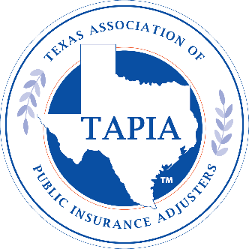
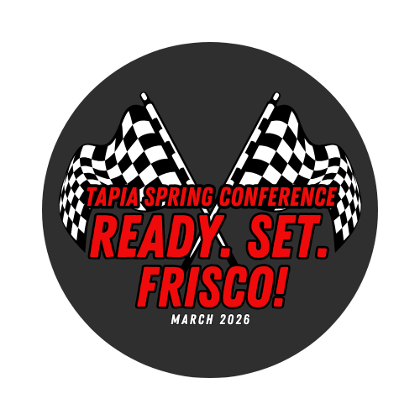

TAPIA’s Conference Committee is seeking presentation proposals for our Spring 2026 Conference, March 9th-11th, 2026 at the Embassy Suites Frisco, TX.

We’re looking for presentations that are centered around hail.
The Conference Committee will give preference to presenters and presentations that:
- Are relevant to the broadest range of a public adjuster audience.
- Meet state requirements for continuing education credits.
- Reflect current events and trends in the industry.
- Are completed according to directions and submitted on time.
- Have not presented to a TAPIA conference in the past 12 months.
Reminder: TDI only issues CE credits for sessions about the technical aspects of public adjusting, including:
- Public adjusting best practices
- Laws and/or regulations
- Consumer protection
- Ethics
- Business management (related to adjusting losses)

Richard May, Executive Director
TAPIA@mytapia.org
512-567-5972

Presentation Proposal for Spring 2026 Conference / March 9th-11th / Frisco, TX
***Proposal Deadline is Friday, January 16th, 2026***
Thank you for your interest in speaking at the Texas Association of Public Insurance Adjusters conference. TAPIA strives for a meaningful education experience that reflects the interests of our members beyond merely satisfying Texas continuing education requirements.
Who is the primary contact for this proposal?
First Name __________________________________ Last Name _______________________________
Title _______________________________________ Company ________________________________
Phone _______________________ Email __________________________________________________

PROPOSAL AGREEMENT
- By submitting this proposal, I am making a professional commitment to present at the TAPIA Conference. If I become unable to present for any reason, I will contact TAPIA immediately via email to
- TAPIA@mytapia.org.
- I understand the importance of submitting a thorough timed outline (by following the template in this packet) no later than the January 16th, 2026, deadline.
- If accepted, I understand that TAPIA will schedule my presentation according to what is best for the attendees. TAPIA will try—but cannot commit—to fulfill special scheduling requests.
- I understand that if I wish to attend any conference sessions or events, I must register for the conference. Speakers do not receive a complimentary registration.
- I affirm that this proposal is focused on education and information for public adjusters and is not intended to sell or promote products or services.
- I understand that only TAPIA reserves the right to record and post my presentation to the Members Only section of the TAPIA website.
- I agree to provide all requested information for my proposal and understand incomplete proposals will not be considered by reviewers.
- For virtual classes, I agree to participate in a Zoom webinar practice session in advance of the presentation.
Signature ____________________________________________ Date _______________________

PRESENTATION PROPOSAL
***What is the title of the presentation?
IMPORTANT: Please complete the timed outline blank on the following pages. It conforms to TDI requirements for CE credit session. Proposals that don’t adhere to the format will be returned to the sender and will not be included in the selection process unless they are resubmitted before the deadline). Call or send email to TAPIA@mytapia.org if you have questions or need samples of successful submissions.

Continuing Education Category: Select the category that best describes your presentation.

___Technical aspects of public adjusting
___ Laws and/or regulations
___ Consumer protection
___ Ethics
___ Management of insurance firm
___ Other ________________________________

What knowledge, skills, and abilities are licensed PAs expected to gain through completion of this course?

How will the session be presented? (e.g., panel presentation, one speaker with slides/handouts, audience participation, etc.)

Audiovisual Needs
___ LCD Projector (project laptop screen)
___ PC Audio (amplify sound from your laptop)
___ Tabletop or podium microphone(s) ________
___ Lapel microphone(s) _______
___ Laptop___ Internet connection
___ Flipchart & markers)
___ Whiteboard
___ Other

BIO FOR EACH SPEAKER: 150 words or less on this form. DO NOT attach a resume.

Timed Outline
PLEASE READ: The timed outline is what we submit to TDI to convince reviewers this is a CE-worthy presentation.
- Presentations must be a MINIMUM of 50 minutes (60 is preferred) to qualify for one (1) CE credit.
- It’s important to give enough information in points/subpoints that reviewers can see why the topic is important and how it relates to public adjusters in conducting their work.
- If you are using case studies, field experience, lawsuits, court rulings, etc., include citations/specifics.
- Don’t include more than five (5) minutes for Q&A. It may go longer in the session, but reviewers typically don’t approve outlines with more.

Introduction:
# minutes
1. Main Point:
# minutes
  - Subpoint
  - Subpoint
  - Etc.
2. Main Point:
# minutes
  - Subpoint
  - Subpoint
  - Etc.
3. And so on…
# minutes
  - Subpoint
  - Subpoint
  - Etc.

Proposal Deadline: 5 p.m., Friday, January 16th, 2026
Return completed proposal to: TAPIA@mytapia.org

